How to Kill Hogweed


Chemical Control Methods
For chemical intervention, you’ll typically use a herbicide such as glyphosate or triclopyr. These are effective weed killers that, when applied properly, can penetrate the plant down to its roots, including the taproot, which is critical for the plant’s survival. Ensure you strictly follow the directions on the herbicide label.
- Glyphosate: Apply a glyphosate-based herbicide to the foliage of hogweed, ensuring thorough coverage to facilitate absorption.
- Triclopyr: If hogweed is near desirable vegetation, consider using a selective herbicide like triclopyr, which is less harmful to grass.
Note: Always wear protective clothing and equipment when handling weed killers to prevent skin contact and inhalation.

🌿 Market Research: Autonomous Robots for Invasive Plant Removal
1. Carbon Robotics – LaserWeeder G2
- Functionality: Utilizes AI-driven computer vision to distinguish between crops and weeds, eliminating the latter with precision lasers.​WIRED+2Reddit+2Carbon Robotics+2
- Key Features:
  - High-precision weed removal without chemicals.​Carbon Robotics+1content.ces.ncsu.edu+1
  - Operates autonomously with real-time plant recognition.​
- Use Case: Suitable for large-scale farming with a focus on reducing herbicide usage.​
- Website: Carbon Robotics
2. FarmWise – Titan FT-35
- Functionality: An automated mechanical weeder that employs AI and computer vision to identify and remove weeds without harming crops.​
- Key Features:
  - Real-time plant detection and mechanical weeding.​
  - Designed for vegetable fields, enhancing sustainability.​
- Use Case: Ideal for vegetable farmers aiming to minimize chemical use.​
- Website: FarmWise Labs
3. Earth Rover – CLAWS
- Functionality: A lightweight, autonomous field robot equipped with AI and GNSS RTK navigation, capable of weeding, scouting, and real-time data analysis.​
- Key Features:
  - Concentrated light weeding technology.​
  - Real-time crop data gathering and analysis.​
- Use Case: Designed for brassicas and lettuce crops, enhancing precision agriculture.​
- Website: Earth Rover
4. Aigen Robotics
- Functionality: Solar-powered, autonomous robots that use cameras to identify and mechanically remove weeds.​
- Key Features:
  - Operates without chemicals, promoting environmental health.​
  - Designed for continuous operation with minimal human intervention.​
- Use Case: Suitable for farmers seeking sustainable weed control methods.​Axios+4Earth Rover+4howtorobot.com+4
- Reference: The Guardian
5. Small Robot Company – Tom and Dick
- Functionality: 'Tom' scans individual plants to detect weeds, while 'Dick' uses an electric "death wand" to eliminate them without chemicals.​WIRED
- Key Features:
  - Precision weed detection and removal.​Wikipedia+1Wikipedia+1
  - Reduces pesticide and fertilizer use significantly.​WIRED+1Wikipedia+1
- Use Case: Ideal for farms aiming to minimize chemical inputs and enhance sustainability.​
- Reference: WIRED
6. Solinftec – Solix AG Robotics
- Functionality: An autonomous robot equipped with solar panels, capable of analyzing plant health, detecting weeds, and applying targeted treatments.​Wikipedia
- Key Features:
  - Real-time field data collection and analysis.​Earth Rover
  - Reduces herbicide usage by up to 95%.​arXiv
- Use Case: Suitable for large-scale farms focusing on precision agriculture and sustainability.​
- Reference: Wikipedia

Odd.Bot (The Weed-Pulling Robot)
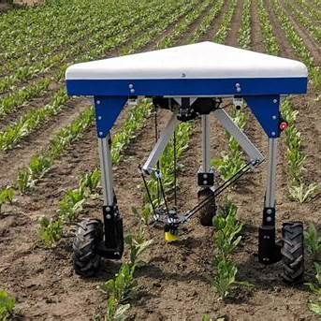

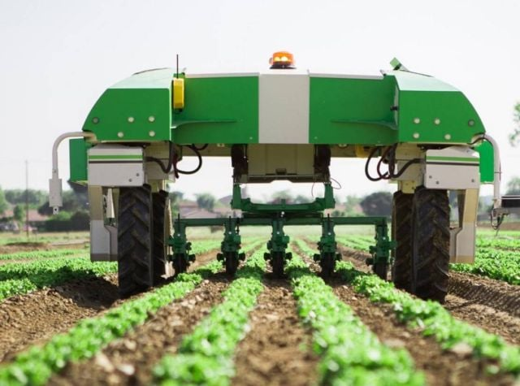

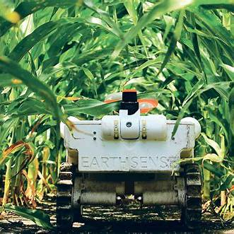

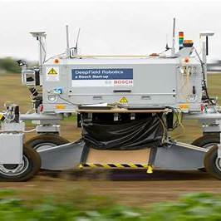

🤖 Advanced Robotic Systems for Invasive Plant Removal
1. Carbon Robotics – Autonomous Laser Weeder
- Functionality: Utilizes high-power lasers combined with AI-driven computer vision to identify and eliminate weeds without disturbing the soil.​Communiqué de Presse & Relations Investisseurs
- Key Features:
  - Chemical-free weed removal, promoting organic farming practices.​lccmr.mn.gov+2Eden Brothers+2Communiqué de Presse & Relations Investisseurs+2
  - Operates autonomously, reducing labor costs.​Perennial Sport & Turf+6YouTube+6Rose-Hulman Institute of Technology+6
- Use Case: Effective for large-scale farming operations targeting various invasive species.​
- Video Demonstration: Carbon Robotics – Autonomous Laser Weeder
2. Odd.Bot – The Weed-Pulling Robot
- Functionality: A mechanical weeding robot that identifies and physically removes weeds without the use of chemicals.​Ideal Home+2High Country Gardens+2Perennial Sport & Turf+2
- Key Features:
  - Equipped with AI for plant recognition.​
  - Environmentally friendly, targeting weeds like common ragwort.​
- Image:
- More Information: Odd.Bot – Intelligent Living
3. Dino – Autonomous Mechanical Weeding Robot
- Functionality: An autonomous robot designed for mechanical weeding in vegetable crops.​
- Key Features:
  - Uses GPS and cameras for navigation and weed detection.​YouTube+6Communiqué de Presse & Relations Investisseurs+6GitHub+6
  - Suitable for organic farming, reducing the need for herbicides.​Communiqué de Presse & Relations Investisseurs
- Image:
- More Information: Dino – WordlessTech

🌿 Specific Invasive Plant Removal Techniques
Giant Hogweed (Heracleum mantegazzianum)
- Manual Removal: Due to its toxic sap, manual removal requires protective clothing. The plant should be cut and the roots excavated.​Home
- Video Demonstration: How to Remove Giant Hogweed
Common Ragwort (Jacobaea vulgaris)
- Manual Removal: Often removed manually using tools like the Rag-Fork to extract the plant and its roots.​
- Video Demonstration: Removing Ragwort at Home

